---########### Day 3 ###########---

------USE Northwind from Kaggle:-------

---*********** 1) Update the categoryName From “Beverages” to "Drinks" in the categories table.***********---

UPDATE categories

SET categoryName = 'Drinks'

WHERE categoryName = 'Beverages';

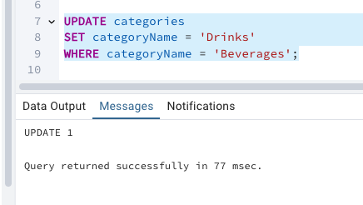

select * from categories

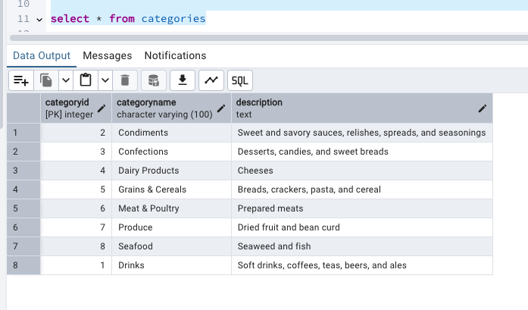

---*********** 2) Insert into shipper new record (give any values) Delete that new record from shippers table.***********---

-- Part 1 Insert a new shipper

INSERT INTO shippers (shipperID, companyName)

VALUES (999, 'FastTrack Shipping');

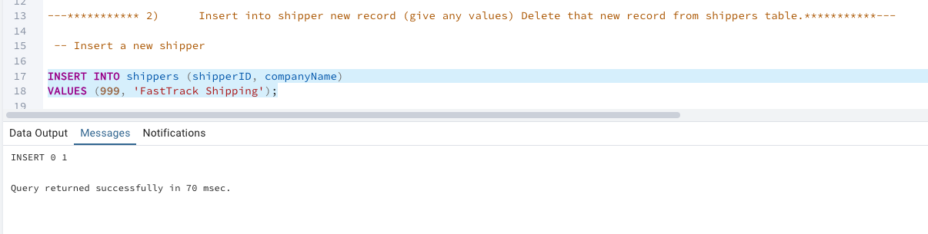

Select * from shippers where shipperID = 999

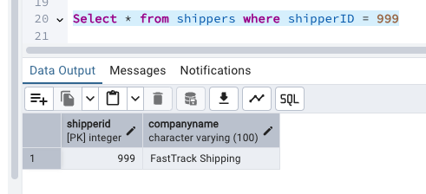

-- Part 2 Delete that shipper

DELETE FROM shippers

WHERE shipperID = 999;

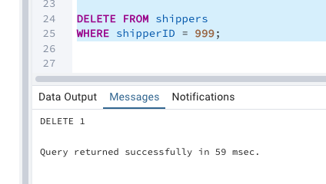

After delete

Select * from shippers where shipperID = 999

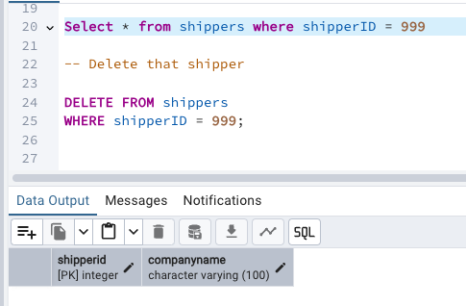

---***********

/* 3) Update categoryID=1 to categoryID=1001. Make sure related products update their categoryID too. Display the both category and products table to show the cascade.

Delete the categoryID= “3” from categories. Verify that the corresponding records are deleted automatically from products.

(HINT: Alter the foreign key on products(categoryID) to add ON UPDATE CASCADE, ON DELETE CASCADE)*/--***********---

**---Update categoryID=1 to categoryID=1001. Make sure related products update their**

**--categoryID too. Display the both category and products table to show the cascade.**

--STEP#1 - Alter FK constraint in products to cascade

-- Dropping existing FK constraint

ALTER TABLE products DROP CONSTRAINT fk_products_category;

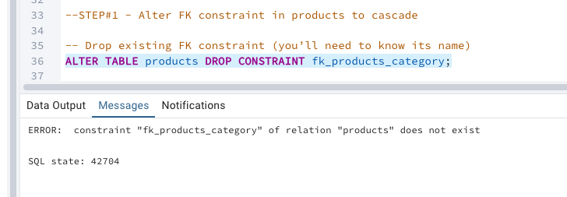

---Finding constraints

SELECT conname

FROM pg_constraint

WHERE conrelid = 'products'::regclass

AND contype = 'f';

"products_categoryid_fkey"

"fk_product_category"

-- Drop existing FK constraint (you’ll need to know its name)

ALTER TABLE products DROP CONSTRAINT products_categoryid_fkey;

ALTER TABLE products DROP CONSTRAINT fk_product_category;

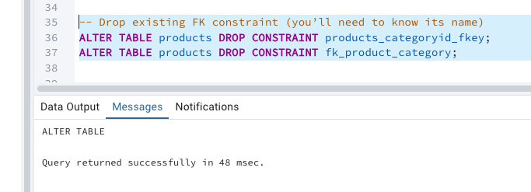

---Checking constraints removed?

SELECT conname

FROM pg_constraint

WHERE conrelid = 'products'::regclass

AND contype = 'f';

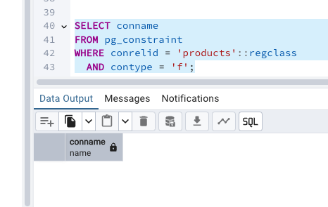

-- Recreating FK with ON UPDATE CASCADE, ON DELETE CASCADE

ALTER TABLE products

ADD CONSTRAINT fk_products_category

FOREIGN KEY (categoryID)

REFERENCES categories(categoryID)

ON UPDATE CASCADE

ON DELETE CASCADE;



-- Recreating FK with ON UPDATE CASCADE, ON DELETE CASCADE

ALTER TABLE products

ADD CONSTRAINT fk_products_category

FOREIGN KEY (categoryID)

REFERENCES categories(categoryID)

ON UPDATE CASCADE

ON DELETE CASCADE;

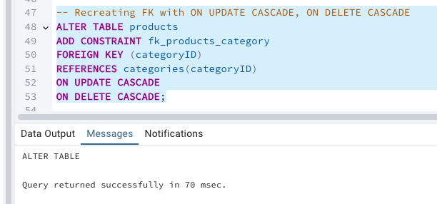

-- -Checking products table on the fk alteration

SELECT conname

FROM pg_constraint

WHERE conrelid = 'products'::regclass

AND contype = 'f';

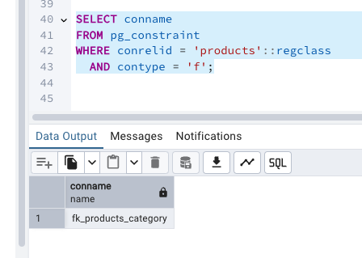

-- STEP#2 - updating Category ID

UPDATE categories

SET categoryID = 1001

WHERE categoryID = 1;

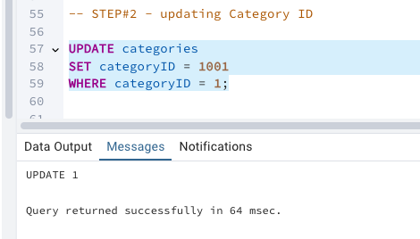

-- STEP#3 - Display updated tables

SELECT * FROM categories WHERE categoryID = 1001;

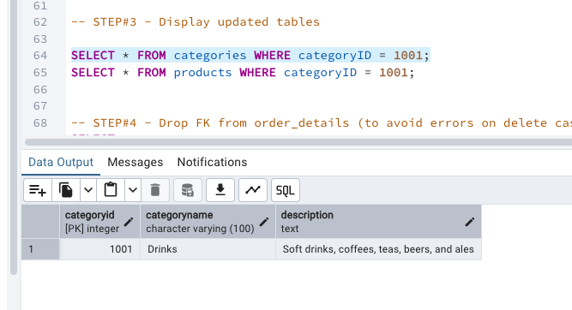

SELECT * FROM products WHERE categoryID = 1001;

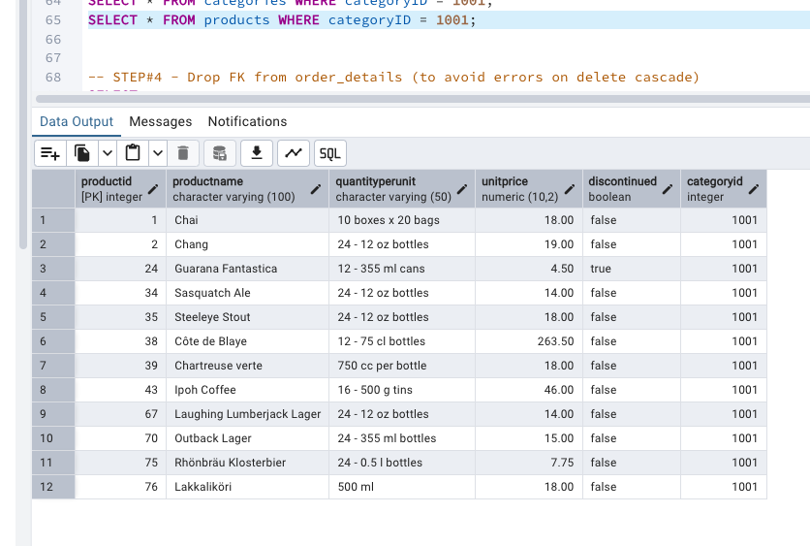

-- STEP#4 - Drop FK from order_details (to avoid errors on delete cascade)

SELECT conname

FROM pg_constraint

WHERE conrelid = 'order_details'::regclass

AND contype = 'f';

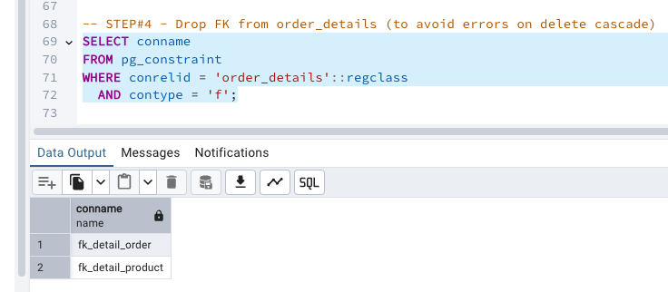

ALTER TABLE order_details DROP CONSTRAINT fk_detail_product;

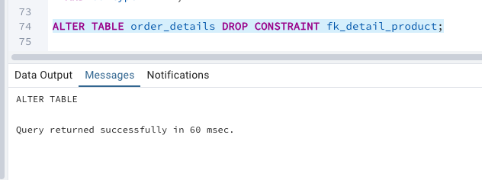

---checking constraint alteration

SELECT conname

FROM pg_constraint

WHERE conrelid = 'order_details'::regclass

AND contype = 'f';

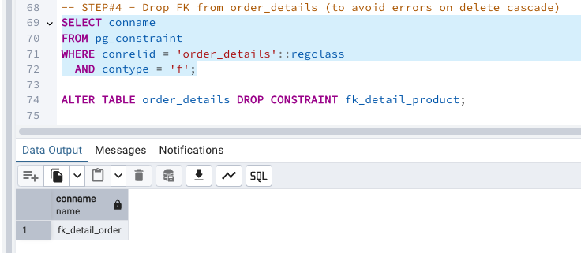

-- STEP#5 - Delete categoryID = 3

DELETE FROM categories WHERE categoryID = 3;

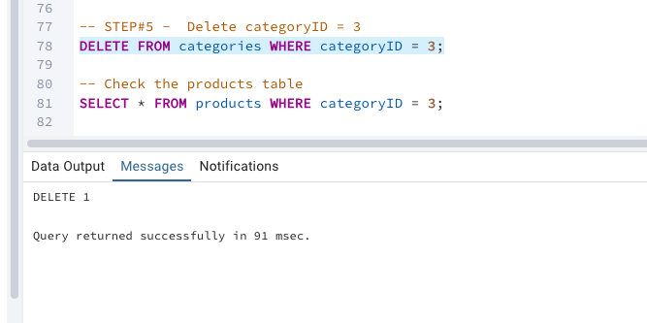

-- Check the products table

SELECT * FROM products WHERE categoryID = 3;

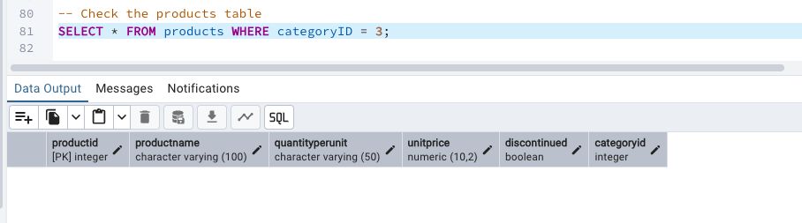

---*********** 4) Delete the customer = “VINET” from customers. Corresponding customers in orders table should be set to null

--(HINT: Alter the foreign key on orders(customerID) to use ON DELETE SET NULL)

--Altering FK

SELECT conname

FROM pg_constraint

WHERE conrelid = 'orders'::regclass

AND contype = 'f';

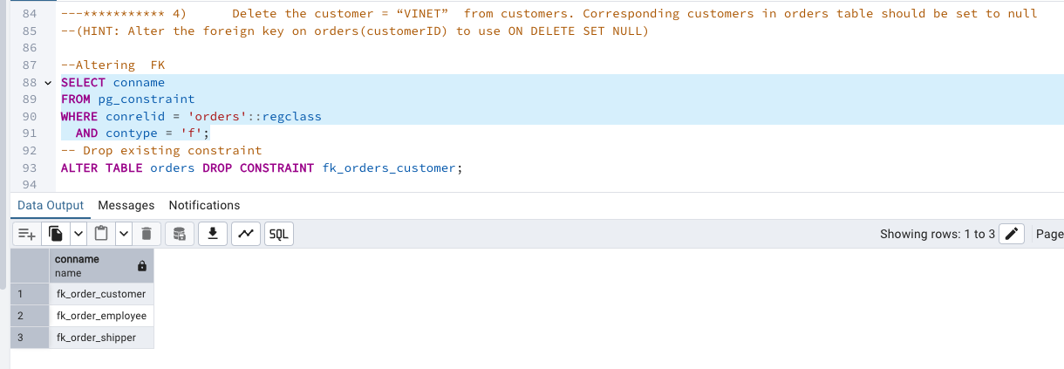

-- Drop existing constraint

--ALTER TABLE orders DROP CONSTRAINT fk_orders_customer; -- this does not work

ALTER TABLE orders DROP CONSTRAINT "fk_order_customer";

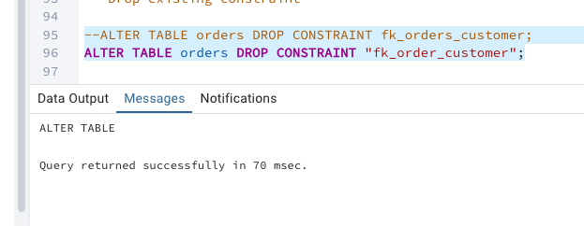

--checking fk alteration

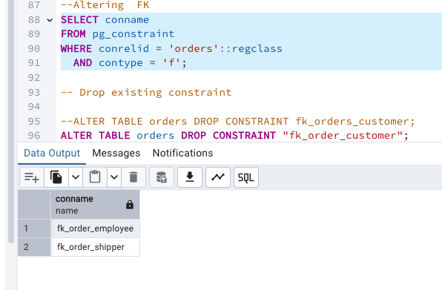

-- Add new constraint with SET NULL on delete

ALTER TABLE orders

ADD CONSTRAINT fk_orders_customer

FOREIGN KEY (customerID)

REFERENCES customers(customerID)

ON DELETE SET NULL;

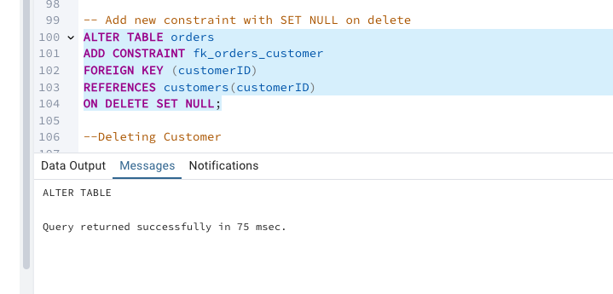

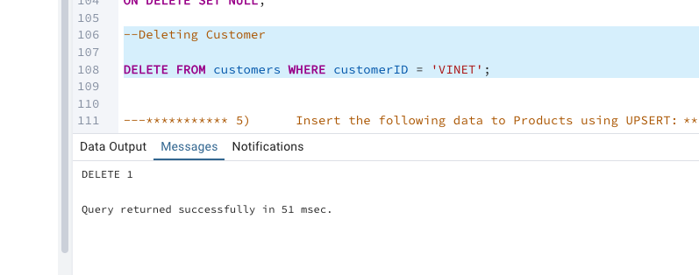

--cross verifying delete

Select *from customers where customerID = 'VINET';

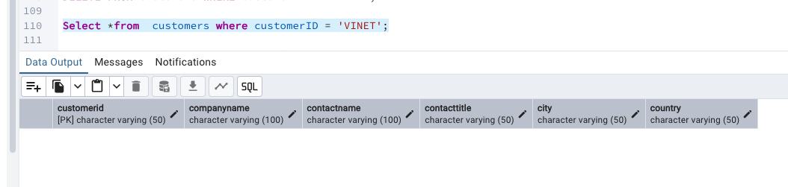

---*********** 5) Insert the following data to Products using UPSERT: ***********---

/*product_id = 100, product_name = Wheat bread, quantityperunit=1,unitprice = 13, discontinued = 0, categoryID=3

product_id = 101, product_name = White bread, quantityperunit=5 boxes,unitprice = 13, discontinued = 0, categoryID=3

product_id = 100, product_name = Wheat bread, quantityperunit=10 boxes,unitprice = 13, discontinued = 0, categoryID=3

(this should update the quantityperunit for product_id = 100)*/

--as per Chaitra's Slack suggestion / UPSERT with new product_new table

--Step1 Create new table

CREATE TABLE product_new (

productID INT PRIMARY KEY,

productName VARCHAR(255),

quantityPerUnit VARCHAR(100),

unitPrice DECIMAL(10,2),

discontinued INT,

categoryID INT

);

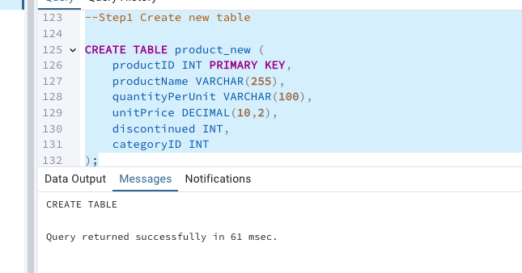

--Step2 Importing CSV in product_new table via import option

--Import product.csv

---Step 3 UPSERT queries

-- First insert Wheat and White bread

INSERT INTO product_new (productID, productName, quantityPerUnit, unitPrice, discontinued, categoryID)

VALUES

(100, 'Wheat bread', '1', 13, 0, 3),

(101, 'White bread', '5 boxes', 13, 0, 3)

ON CONFLICT (productID) DO UPDATE

SET quantityPerUnit = EXCLUDED.quantityPerUnit;

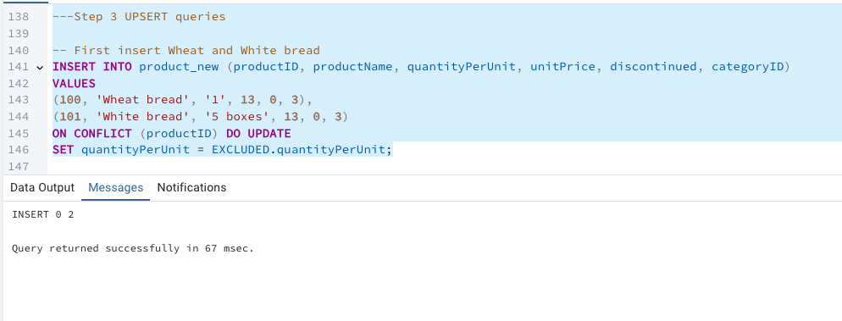

--checking insert operation

Select *from product_new where productName in ('Wheat bread','White bread');

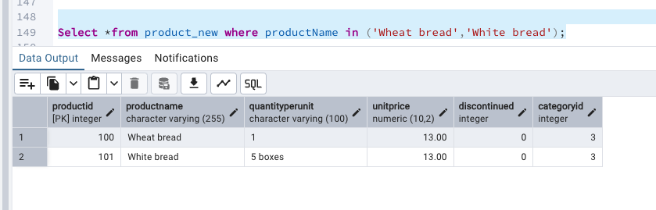

INSERT INTO product_new (productID, productName, quantityPerUnit, unitPrice, discontinued, categoryID)

VALUES

(100, 'Wheat bread', '10 boxes', 13, 0, 3)

ON CONFLICT (productID) DO UPDATE

SET quantityPerUnit = EXCLUDED.quantityPerUnit;

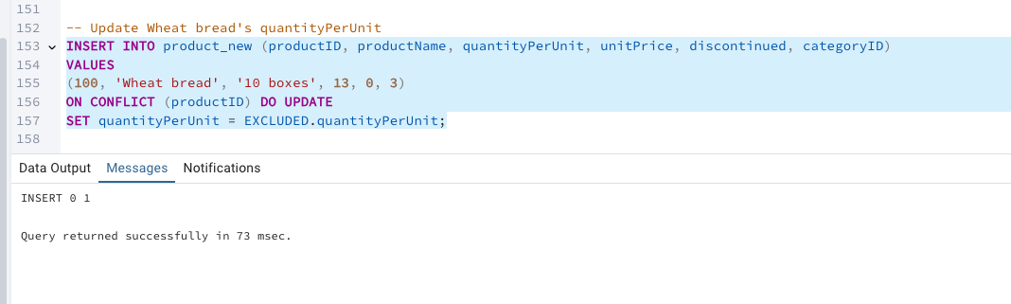

Select *from product_new where productName in ('Wheat bread','White bread');

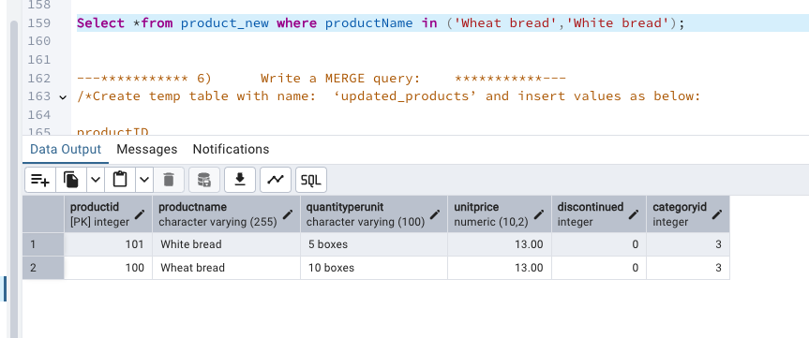

---*********** 6) Write a MERGE query: ***********---

/*Create temp table with name: ‘updated_products’ and insert values as below:

productID

productName

quantityPerUnit

unitPrice

discontinued

categoryID

100

Wheat bread

10

20

1

3

101

White bread

5 boxes

19.99

0

3

102

Midnight Mango Fizz

24 - 12 oz bottles

19

0

1

103

Savory Fire Sauce

12 - 550 ml bottles

10

0

2*/

-- Create temp table and insert values

CREATE TEMP TABLE updated_products (

productID INT PRIMARY KEY,

productName VARCHAR(255),

quantityPerUnit VARCHAR(100),

unitPrice DECIMAL(10,2),

discontinued INT,

categoryID INT

);

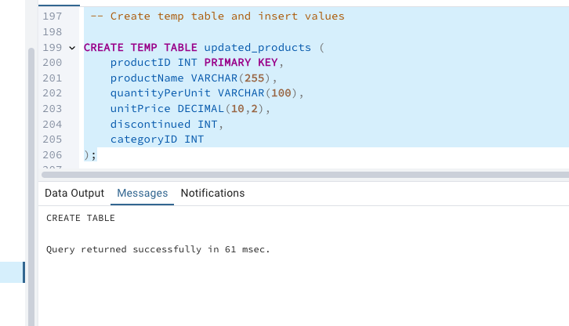

INSERT INTO updated_products VALUES

(100, 'Wheat bread', '10', 20, 1, 3),

(101, 'White bread', '5 boxes', 19.99, 0, 3),

(102, 'Midnight Mango Fizz', '24 - 12 oz bottles', 19, 0, 1),

(103, 'Savory Fire Sauce', '12 - 550 ml bottles', 10, 0, 2);

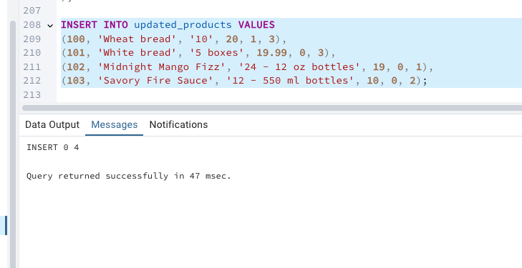

---*********** Update the price and discontinued status for from below table ‘updated_products’ only if there are matching products and updated_products .discontinued =0 ***********---

SELECT

productID,

productName,

quantityPerUnit,

unitPrice,

discontinued,

categoryID

FROM product_new

ORDER BY productID;

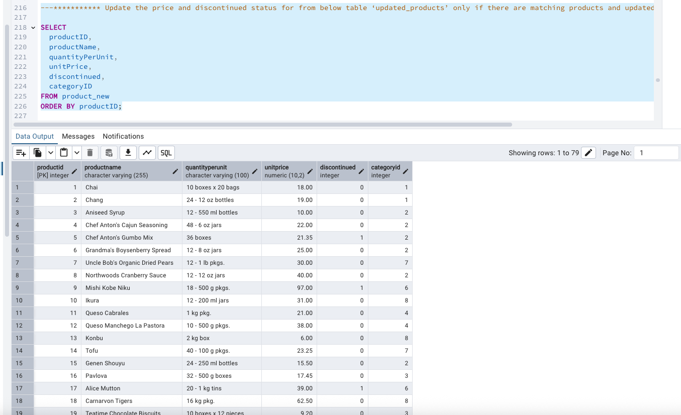

SELECT

productID,

productName,

quantityPerUnit,

unitPrice,

discontinued,

categoryID

FROM updated_products

ORDER BY productID;

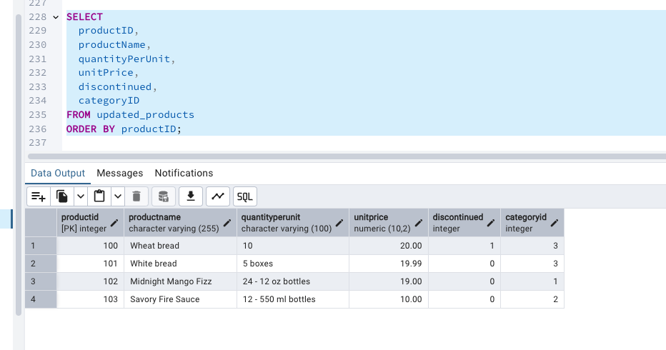

-- Update matching and discontinued = 0

UPDATE product_new p

SET unitPrice = u.unitPrice,

discontinued = u.discontinued

FROM updated_products u

WHERE p.productID = u.productID

AND u.discontinued = 0;

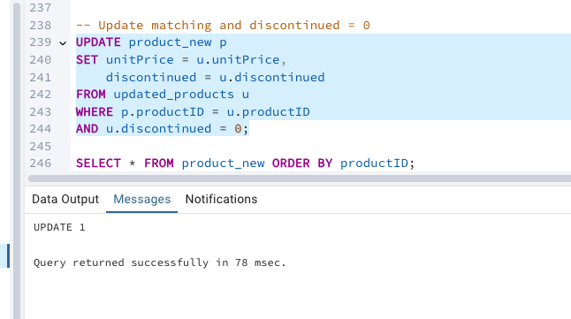

SELECT

productID,

productName,

quantityPerUnit,

unitPrice,

discontinued,

categoryID

FROM product_new

WHERE discontinued = 0

AND productID IN (100, 101) -- These products should be updated

ORDER BY productID;

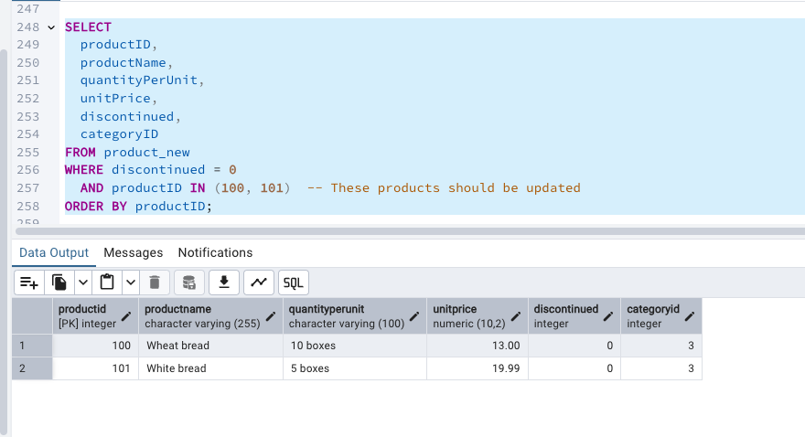

---*********** If there are matching products and updated_products .discontinued =1 then delete ***********---

-- Delete if matching and discontinued = 1

DELETE FROM product_new

USING updated_products u

WHERE product_new.productID = u.productID

AND u.discontinued = 1;

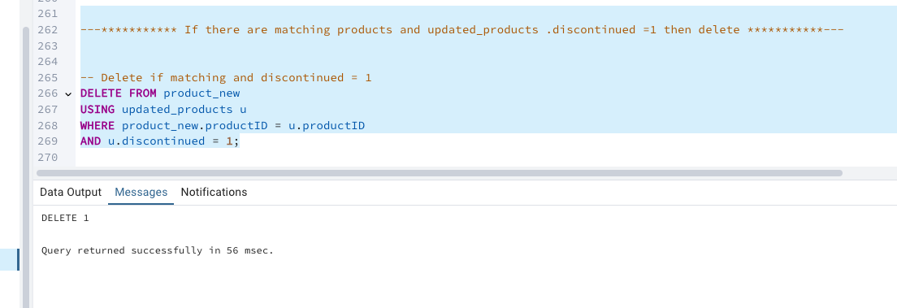

SELECT

productID,

productName,

quantityPerUnit,

unitPrice,

discontinued,

categoryID

FROM product_new

WHERE discontinued = 1

AND productID IN (102) -- Product with productID 102 should be deleted (discontinued)

ORDER BY productID;

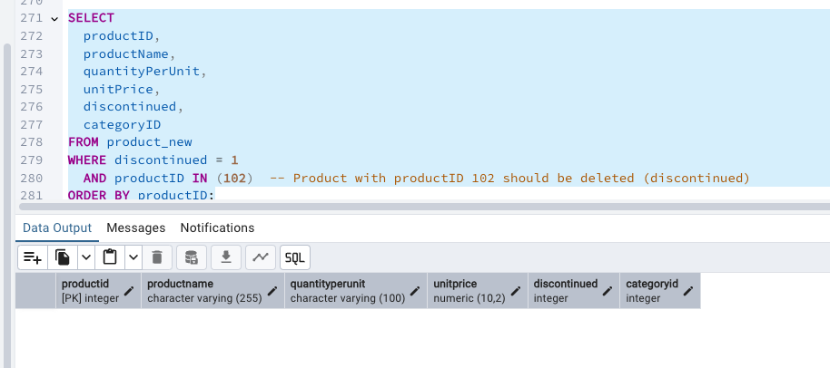

---*********** Insert any new products from updated_products that don’t exist in products only if updated_products .discontinued =0.***********---

-- Insert new if not exists and discontinued = 0

INSERT INTO product_new (productID, productName, quantityPerUnit, unitPrice, discontinued, categoryID)

SELECT u.productID, u.productName, u.quantityPerUnit, u.unitPrice, u.discontinued, u.categoryID

FROM updated_products u

WHERE NOT EXISTS (

SELECT 1 FROM product_new p WHERE p.productID = u.productID

)

AND u.discontinued = 0;

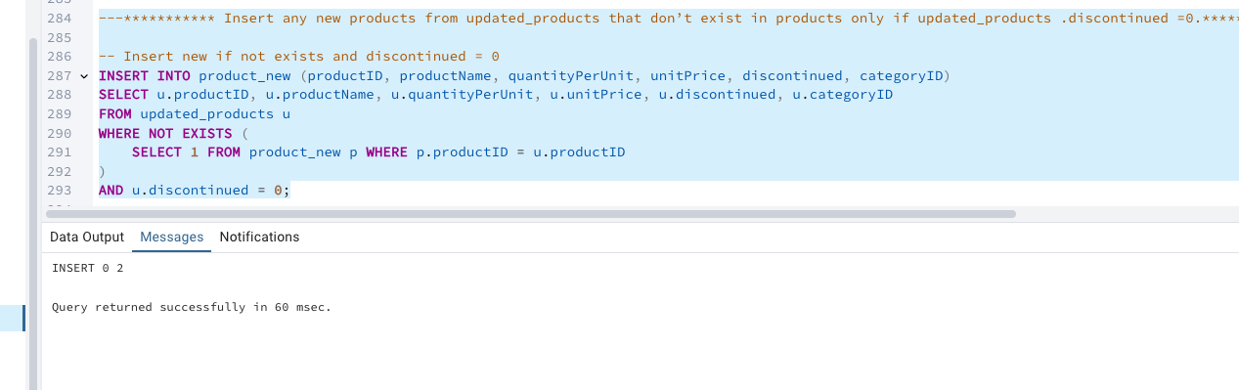

SELECT

productID,

productName,

quantityPerUnit,

unitPrice,

discontinued,

categoryID

FROM product_new

WHERE discontinued = 0

AND productID IN (103) -- This product should be inserted (discontinued = 0)

ORDER BY productID;

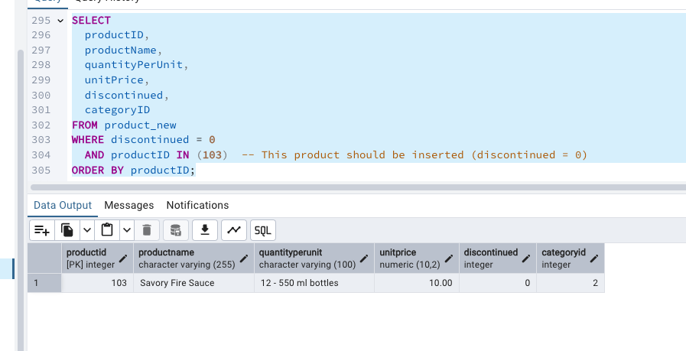

SELECT

productID,

productName,

quantityPerUnit,

unitPrice,

discontinued,

categoryID

FROM product_new

ORDER BY discontinued DESC, productID;

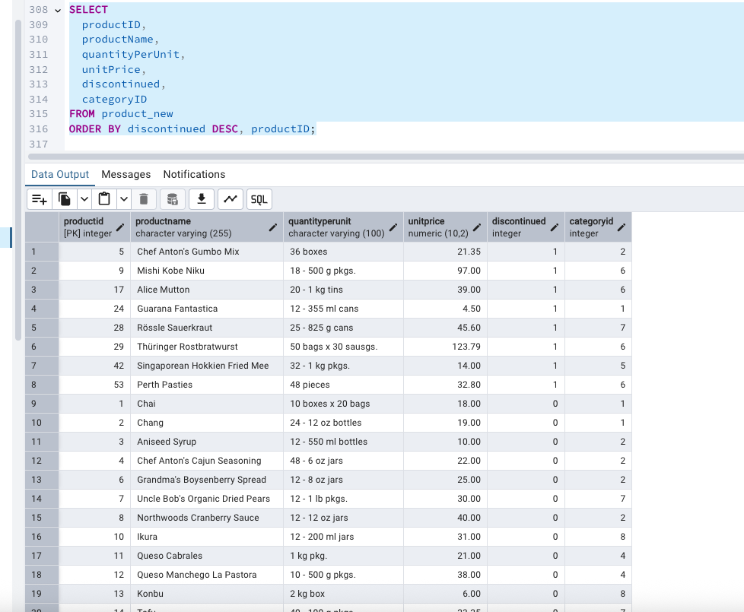

---*********** USE NEW Northwind DB:***********---

---*********** 7) List all orders with employee full names. (Inner join)***********---

SELECT

o.order_id,

o.order_date,

e.first_name || ' ' || e.last_name AS employee_full_name

FROM

orders o

INNER JOIN

employees e ON o.employee_id = e.employee_id;

